Reinforcement Unit – 11th grade
Worksheet 1
(Esta guía debe ser enviada el 25 de marzo)
- VOCABULARY
Study the following lists of vocabulary.
Education | Things to do on Vacation | Illnesses | injuries
Be early / late / on time | Buy souvenirs | A Backache | Break an arm (or any limb of your body)
Study for tests | Eat out | A Headache | Bruise your knee (or any part of your body)
Pass or Fail a test / course | Take pictures | A Earache | Burn your hand (or any part of your body)
Ask / answer questions | Visit a museum | A Stomachache | Cut your finger (or any part of your body)
Give a presentation | Go sightseeing | A Cold | Get an insect bite
Do homework / a project | Take a tour | A Sore throat | Get a blister
Get a good/bad grade on a test | Rent a bike | A Fever | Get a sunburn
Make mistakes | Sunbathe | A Toothache | Graze your leg (or any part of your body)
 | Go hiking | A Rash | Hit your head (or any part of your body)
 | Meet new people | A Cough | Sprain your ankle (or any other joint body)

NOTE: (1) When studying vocabulary, it is important to create connections to other words that make sense to you. You can relate the words you need to learn to others that usually go together (collocation) as in the Education list, or that are used in the same context. You can also mark the differences or similarities that exist between words that you already know or that are easy to understand.
(2) The only real way to learn vocabulary is using it. So every time you have new words to learn in any language, use them as many times as possible. Write examples where you use the word in context, express yourself using it, find it in songs, texts and videos.
(3) You should not only learn how words are written; you should learn how they sound. If you don’t have a teacher to help you at the moment you need it, use google translator or online dictionaries where you can hear the word’s pronunciation by pressing the speaker symbol.

Exercise:
- Re-write the following sentences using the vocabulary about education (there’s more than one option):
a) I never get less than 60% on tests. _______________________________________________
b) Bruno has never gotten detention because of tardiness. ___________________________________
c) She got a 6.0 average last year. __________________________________________
d) Young children only study and practice for their class at school. ______________________________
e) Tomorrow I have to speak in front of the class about climate change. ________________________________________________________
f) I always get discounts on tests because I don’t write words correctly.
________________________________________________________

- Write what other terms you can contextually relate to each of the activities to do on vacation. Then, write a context sentence using the vocabulary and the related terms:
Things to do on Vacation
Vocabulary | Related terms | Context sentence
Buy souvenirs | Gift,
Eat out | Restaurant,
Take pictures | Camera,
Visit a museum | Art,
Go sightseeing | Landmarks,
Take a tour | Tour guide,
Rent a bike | Ride,
Sunbathe | Sunscreen,
Go hiking | Nature,
Meet new people | Talk,

- Complete the sentences using the Illnesses vocabulary:
- Your skin is red. Do you have a _______________?
- You should go to the dentist if you have a _______________.
- When I have a _______________, I can’t breathe through my nose.
- I feel so hot. I’m sure I have a _______________
- You shouldn’t lift heavy boxes if you have a _______________.
- The best thing to do when you have a _______________ is to drink a lot of warm liquid, especially with lemon and honey.

- Match the vocabulary from the Injuries vocabulary to the images below.

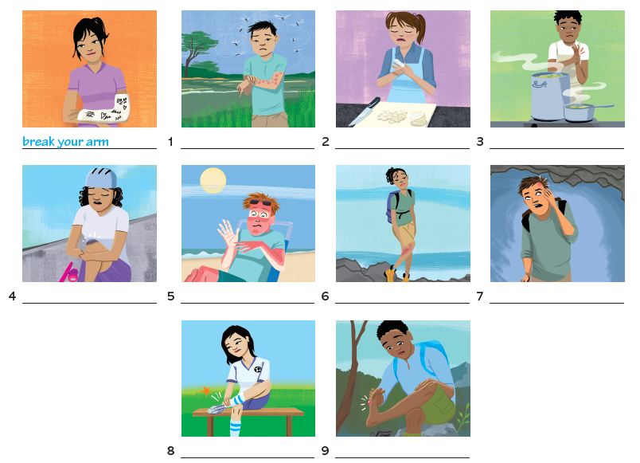

- Now write your own examples using the words and/or phrases that you still need to learn in your notebook.

- GRAMMAR (PART 1)

- Permission
To talk about permission, we use the following:
- CAN (for present):
  - subject + can + verb infinitive I can go to parties. You can’t smoke in public places.
- COULD (for past):
  - subject + could + verb infinitive I could wear normal clothes at school. He couldn’t drive at 16.
- BE ALLOWED TO (for past, present and future): in this case, what marks time is the tense of BE, therefore:
  - Subject + be in appropriate tense + allowed to + verb infinitive
I am allowed to drive, because I’m 20.
she wasn’t allowed to have a boyfriend when she was 15.
You will be allowed to vote when you turn 18.
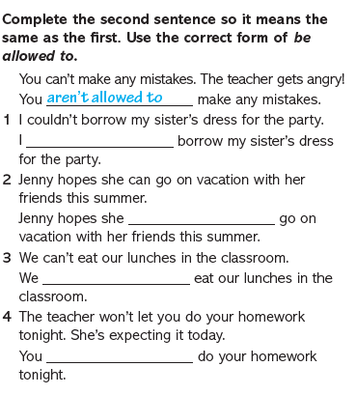
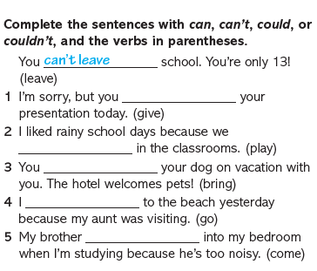
Exercises:
- Past habit
There is a difference between speaking about a particular past event (even if it happened more than once) and speaking about past habits. To highlight situations when you want to express past habits to use the construction USED TO, which is translated as “solía”:
- USED TO is a simple past construction, so when it is affirmative it is marked with -ed:
  - Subject + used to + action.
  - For example: He used to practice karate, but now he doesn’t.
- When it is negative or a question, the -ed is lost because we use DID to mark past tense:
  - Subject + did not + use to + action.
  - Did + subject + use to + action?
  - For example: Did he use to ride his bike to school when he was younger? No, he didn’t.
My father didn’t use to watch a lot of TV when he was young.
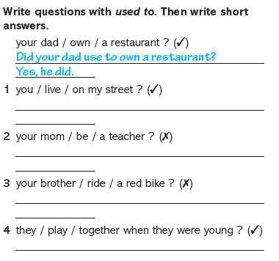
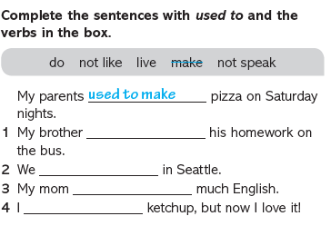
Exercises:

